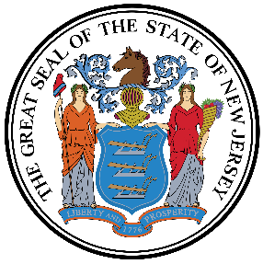

NJ Civil Service Commission
Center for Learning and Improving Performance
P.O. Box 312
Trenton, NJ 08625

I would like to receive a credit award from Thomas Edison State University for my New Jersey Certified Public Manager (CPM) certification.

Please provide verification of my completed certificate(s) to transcripts@tesu.edu

First Name
Middle Name
Last Name
Email Address
Cohort Name
Capstone Project Name
Department Name
Date of Completion

Complete this form and email to NJCPM@csc.nj.gov

